**Best Sites/Institutes for Online Engineering Entrance Preparation in Nepal**

It takes at least three months to get the results of the grade XII annual exam. During this period, students can utilize their time for different purposes like creative activities, learn a skill, fulfill a hobby, or prepare for the entrance exams of various educational programs. Different colleges and universities take their entrance exam before admitting students in Bachelors.



Tribhuwan University, Kathmandu University, Pokhara University, Purbanchal University, etc are some renowned universities in Nepal offering various engineering courses in Nepal. Institute of Engineering(TU) is the first priority of many students. There is fierce competition to get into good engineering campus/college with the field of own choosing in Nepal. Every year, thousands of students take the engineering entrance exam, but not all become successful. For many students, online engineering entrance preparation is a great way to improve their chances of getting into their dream college.

Here are some of the benefits of online engineering entrance preparation:

* **Flexibility:** Online courses can be accessed from anywhere, at any time, which gives you the flexibility to study at your own pace and on your own schedule.
* **Affordability:** Online courses are far more affordable than traditional classroom(physical) courses.
* **Convenience:** Online courses can be completed from the comfort of your own home, which can save you time and money on transportation and other expenses like hostel in Kathmandu.
* **Personalized attention:** Many online courses offer live chat or video conferencing with instructors, mentors which allows you to get personalized attention and help as needed.
* **Access to resources:** Online courses often have access to a wide range of resources, such as practice questions, study guides, recorded lectures, daily/weekly mock test and video tutorials.
* **Community:** Many online courses have online forums or discussion boards(Facebook, Discord, telegram group) where you can connect with other students and share ideas.

There are many different online engineering entrance preparation institutes available in Nepal. Some of them are:

1. **Clamphook Academy.**

Clamphook Academy is an online and physical engineering entrance preparation institute founded in 2019 by Er. Bikki Chhantyal, who is an alumnus of IOE Pulchowk campus. It offers a variety of online courses for students preparing for engineering entrance exams in Nepal, including the IOE entrance exam, PSC and the CSIT entrance exam.

Its courses are taught by experienced and qualified instructors who are experts in engineering entrance preparation. It offers a variety of resources to help students succeed, including practice questions, online weekly mock test, study guides, and video tutorials.

It has gain huge success in few with help of positive word of mouth and facilities like Computer based weekly mock test, collection of memory based Past questions. Its website has more than 50k questions for practice. The teachers team consists of young, energetic and talented past toppers and decades experienced teachers from IOE Pulchowk and other colleges.

Its fee is Rs. 10k for Online classes.

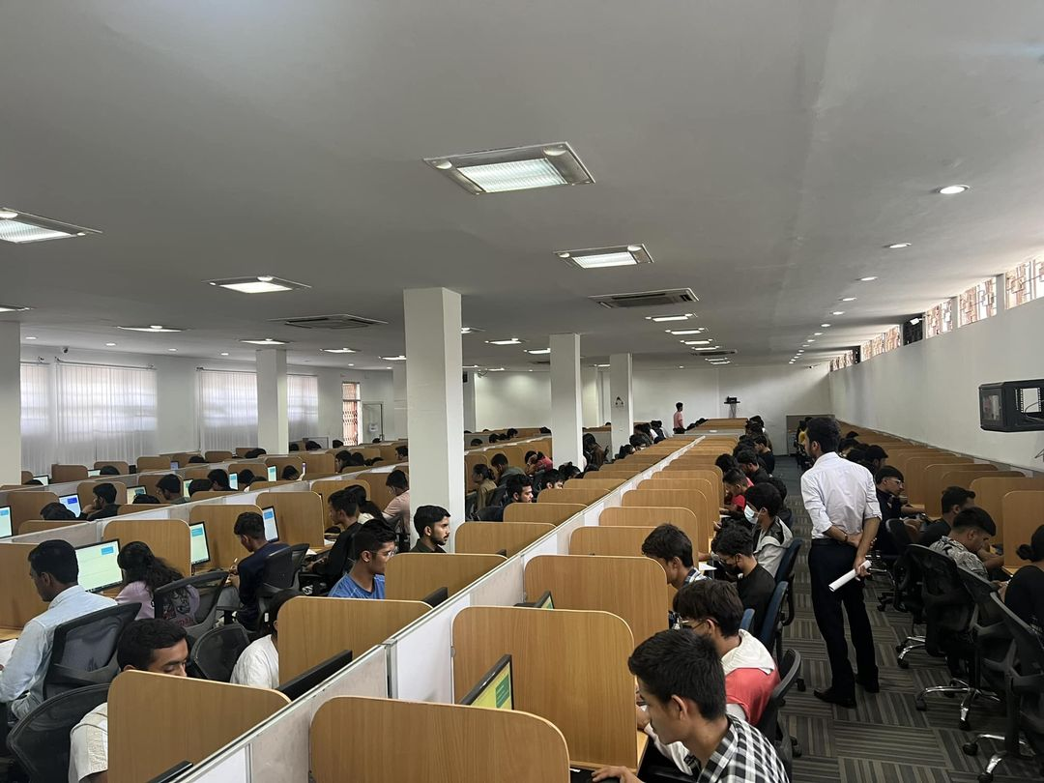

Pic: students taking weekly computer-based test.

If you are interested in learning more about Clamphook Academy, you can visit their website or contact them through their social media channels.

Website: [www.clamphook.com](http://www.clamphook.com)

1. **PEA Mentors, Engineering dote.**

PEA Association Pvt. Ltd. is a leading engineering entrance preparation institute in Nepal. It was initiated by Er. Laxman Pokharel a graduate of Pulchowk Campus, in 1994. PEA Association offers a variety of online and physical courses for students preparing for engineering entrance exams in Nepal, including the IOE entrance exam, PSC, BE tuition classes, and the CSIT entrance exam. It has been helping students prepare for engineering entrance exams in Nepal for over 30 years.

PEA Association's courses are taught by decades experienced and qualified instructors who are experts in engineering entrance preparation. PEA Association also offers a variety of resources to help students succeed, including practice questions, study guides, and video tutorials. ***PEA Engineering dote*** has more than 50k practice questions. And ***PEA mentors*** have over 350 hours of recorded lecture.

Its fee is Rs. 15k and 7k for Online classes and PEA Mentors subscription respectively.



Pic: PEA building

If you are interested in learning more about PEA, you can visit their website or contact them through their social media channels.

Website: [www.pea.edu.np](http://www.pea.edu.np)

1. **Ambition Guru**

Ambition guru is an AI-driven ed-tech platform that guides learners to be the best at anything they desire. You can also prepare for the engineering entrance exam on this platform, which conducts class 11th and 12th classes, higher education and public service commission exams conducted by the government online.

Apart from engineering, entrance exams for BSc. CSIT, CEE, Loksewa, SEE Bridge Course and other courses are available too.

Students can take an AI-based 'mock test' on it. Students can track their performance and see the report. The entrance exam fee on this platform is Rs 2,999.



If you are interested in learning more about Ambition Guru, you can visit their website or contact them through their social media channels.

You can download its app from Playstore.

https://ambition.guru/

1. **Nepal Institute**

Nepal Institute is one of the oldest BE/B. Arch (IOE) entrance preparation institutes in Nepal. They also run classes for CSIT entrance preparation. With the teachers team of decade experience, it is provides quality education, preparation for the entrance examination. It is located in Putalisadak, Kathmandu, Nepal.

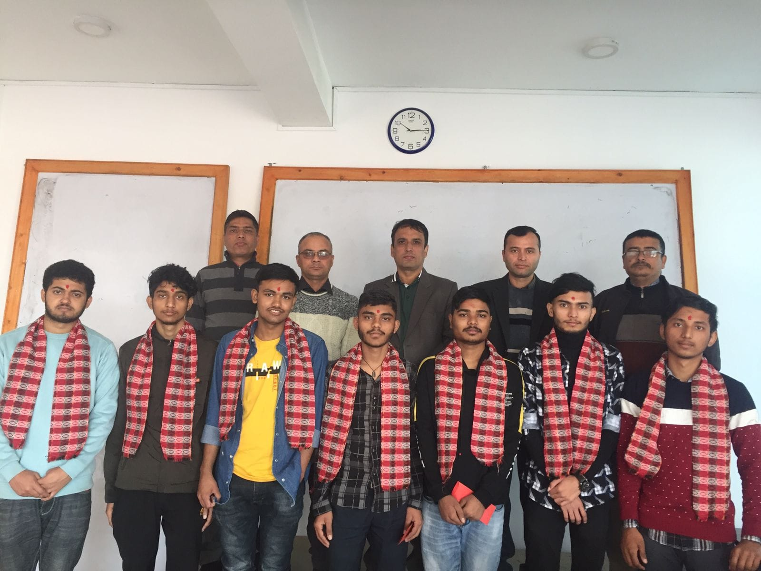

1. **PI Academy**

PI Academy stands as a well-known IOE Entrance Preparation Institute in Nepal. This institute's main objective is to provide a solid groundwork for students aiming to secure admission in BE, B.Arch, and B.Sc.CSIT programs across various universities. Situated in Matighar Mandala, Kathmandu, the academy was established by a team of devoted educators and former students from Pulchowk Campus. This group has garnered more than ten years of experience in the realm of entrance exam preparation. Their unwavering dedication revolves around quenching the thirst for knowledge among engineering enthusiasts, all the while making valuable contributions to nurturing skilled future engineers. This endeavor holds immense significance for the advancement and prosperity of the nation.



**Honorable mentions:**

1. **Beats**
2. **Super Hundred Entrancepedia**
3. **Learnsic**
4. **Aakhyan**

Online engineering entrance preparation can be a great way to learn the material you need to know for the exam, and to get practice answering questions in a timed format. It can also be a great way to connect with other students who are preparing for the exam, and to get support and motivation from your peers.

If you are serious about getting into a good engineering college in Nepal, then online engineering entrance preparation is a great option. There are many different courses available, so you can find one that fits your needs and budget. With hard work and dedication, you can use online engineering entrance preparation to increase your chances of success.

If you are considering online engineering entrance preparation, here are some things to keep in mind:

* Choose a reputable course provider: There are many different online engineering entrance preparation courses available, so it is important to choose one that is reputable and has a good track record.
* Make sure the course is right for you: Not all online engineering entrance preparation courses are created equal. Some courses are more focused on teaching the material, while others are more focused on providing practice questions and mock exams.
* Be prepared to put in the work: Online engineering entrance preparation is not a magic bullet. You will still need to put in the time and effort to learn the material and practice answering questions.

If you are willing to put in the work, online engineering entrance preparation can be a great way to improve your chances of getting into a good engineering college in Nepal.

* *Saroj Basnet, rank 3, IOE BE/BArch Entrance 2077*